A Project Report on YSA NGO Project

by:

Student 1 Abbas ghoghari abarghoghari@gmail.com
Student 2 Yash dhokiya yash @gmail.com

Submitted in partial fulfillment of the requirements for the degree

BCA
October 2025

Guided By
Dr.Riddhi Tanna
Bachelor of Computer Applications
Christ College, Rajkot
(affiliated to Saurashtra University, Rajkot 360 005)

22

Certificate
This is to certify that the work presented in the BCA project report entitled “YSA NGO”, submitted to the Department of Computer Applications, Christ College, Rajkot, in partial fulfilment of the requirements for the award of the Bachelor of Computer Applications, is an authentic record of the work carried out by Abbas Ghogahri and Yash Dhokiya during the period from June 2025 to October 2025 under the supervision of DR.Riddhi Tanna.
We also certify that this work has not been submitted, either in part or full, for the award of any other degree elsewhere.
Signature of Abbas : __________
Signature of Yash: __________

This is to certify that the above statement made by the candidate(s) is/are correct to the best of my knowledge.
Head | Guide
Dr. Shailendrasinh Jadeja | Dr. Riddhi Tanna
Department of Computer Applications | Department of Computer Applications
Christ College, Rajkot | Christ College, Rajkot
Place: Rajkot
Date: __________

Acknowledgement
When we embarked on this project, it initially appeared to us as an onerous task. However, as we progressed, we realized that we were not alone in this journey. We wish to express our sincere gratitude to Rev. Fr. (Dr.) Jomon Thommana, Director, Christ Campus, and Dr. Yvonne Fernandes, Principal, Christ College, for their constant support and encouragement.
We are deeply thankful to Dr.Riddhi Tanna, our project guide, for their invaluable guidance, suggestions, and the freedom they provided us throughout this project. Without their mentorship, the completion of this project would not have been possible.
We also extend our heartfelt thanks to [Faculty Name who helped during your project], our friends for offering their unwavering support, encouragement, and assistance during the preparation of this project.
Our gratitude also goes to our group members, classmates, and well-wishers, whose generous help made this work considerably easier. Finally, our deepest thanks to our parents, who patiently bore with us through the challenges and supported us with a smile throughout our study period and beyond.

Abbas
Yash
Christ College, Rajkot
October 2025

Table of Content

Introduction
This project is developed as part of the academic curriculum to demonstrate the practical application of software engineering principles. The primary objective of the project is to design and implement a solution that addresses a specific problem statement in a systematic and structured manner.
Following the Software Development Life Cycle (SDLC), the project moves through various phases including requirement analysis, system design, implementation, testing, deployment, and maintenance. Each phase ensures that the system is developed efficiently, meets user expectations, and maintains quality standards.
The project not only focuses on delivering a functional system but also emphasizes improving technical proficiency, teamwork, documentation skills, and problem-solving abilities. Ultimately, this project serves as a comprehensive learning experience that bridges the gap between academic concepts and real-world software development practices.

Objectives
The main objective of this project is to design and develop a software solution that effectively addresses the identified gap between online becoming offline to online. It aims to follow a systematic approach by analyzing requirements, creating an appropriate design, implementing the system with reliable coding practices, and ensuring its accuracy through proper testing. The project seeks to deliver a functional and user-friendly system that meets the needs of the end users while maintaining quality and efficiency.
At the same time, the project provides an opportunity for students to strengthen technical skills such as requirement gathering, system design, coding, and testing, while also improving essential soft skills like teamwork, time management, problem-solving, and effective communication. It is intended to build confidence in handling end-to-end project work, prepare students for professional challenges in the IT industry, and develop the ability to deliver a reliable and well-documented system within a defined timeframe.

System Analysis
Problem Definition
In the present scenario, many existing systems and processes still rely on manual methods, which are often time-consuming, error-prone, and inefficient. This creates difficulties in managing information, maintaining accuracy, and ensuring smooth operations. Users often face challenges such as lack of accessibility, limited automation, poor data management, and delays in decision-making.
To overcome these limitations, there is a need for a computerized software solution that streamlines the process, reduces redundancy, improves efficiency, and provides accurate and reliable results. The proposed project is intended to address these issues by analyzing the existing problems, identifying user requirements, and developing a system that offers a practical and user-friendly solution.

Feasibility Study
Before developing the proposed system, it is important to evaluate its feasibility in terms of practicality, cost, and usefulness. A feasibility study helps determine whether the project is viable and worth pursuing. The study can be categorized into the following aspects:
1. Technical Feasibility
The project is technically feasible since the required hardware and software resources are readily available. The development tools, programming languages, and database systems selected are reliable, widely used, and well-supported, ensuring smooth implementation.
2. Economic Feasibility
The system is economically viable because it is developed as part of an academic project, requiring minimal cost. The software tools and platforms used are either open-source or provided by the institution, which reduces expenses. The potential benefits of automation, efficiency, and time-saving outweigh the minimal development cost.
3. Operational Feasibility
The proposed system is user-friendly, efficient, and designed to meet the end-user’s requirements. It simplifies existing manual processes, reduces errors, and ensures accurate results. Users can easily adapt to the system with minimal training, ensuring smooth operation.
4. Schedule Feasibility
The project is scheduled within the academic timeframe (June 15 to October 25). By following the Software Development Life Cycle (SDLC), the phases of analysis, design, implementation, testing, and deployment are well-planned to ensure timely completion.

SDLC
SDLC Timeline for Student Project (June 15 – Oct 25)
1. Planning (June 15 – June 25) → 10 days
- Define project topic & objectives.
- Identify scope (what to include/exclude).
- Assign roles in the team.
- Decide tools/tech (language, DB, IDE).
2. Requirement Analysis (June 26 – July 5) → 10 days
- Collect requirements from guides/mentors.
- Prepare SRS (Software Requirement Specification).
- Finalize project modules & features.
3. System Design (July 6 – July 20) → 15 days
- Create ER diagrams, DFDs, UML diagrams.
- Design database schema.
- Sketch user interface (wireframes).
4. Implementation / Coding (July 21 – Sept 10) → ~50 days
- Divide modules among team members.
- Start coding (frontend + backend + DB).
- Conduct unit testing of each module.
5. Testing & Integration (Sept 11 – Sept 30) → 20 days
- Integrate all modules.
- Do system testing (functional, usability, security).
- Debug & fix errors.
- Prepare test report.

6. Deployment / Finalization (Oct 1 – Oct 10) → 10 days
- Deploy on system (or demo environment).
- Ensure all features work as expected.
- Take feedback from faculty/peers.
7. Documentation & Submission Prep (Oct 11 – Oct 25) → 15 days
- Complete final project report.
- Add diagrams, screenshots, testing results.
- Prepare PPT for viva/demo.
- Final review & submission.

System Design
DFD
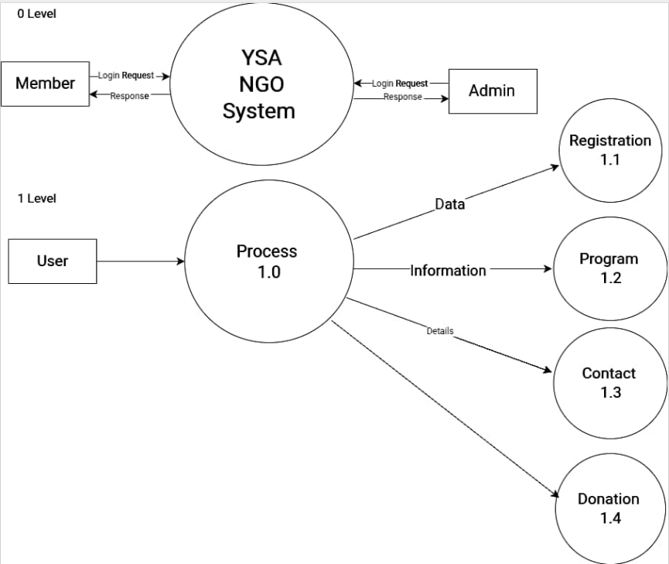

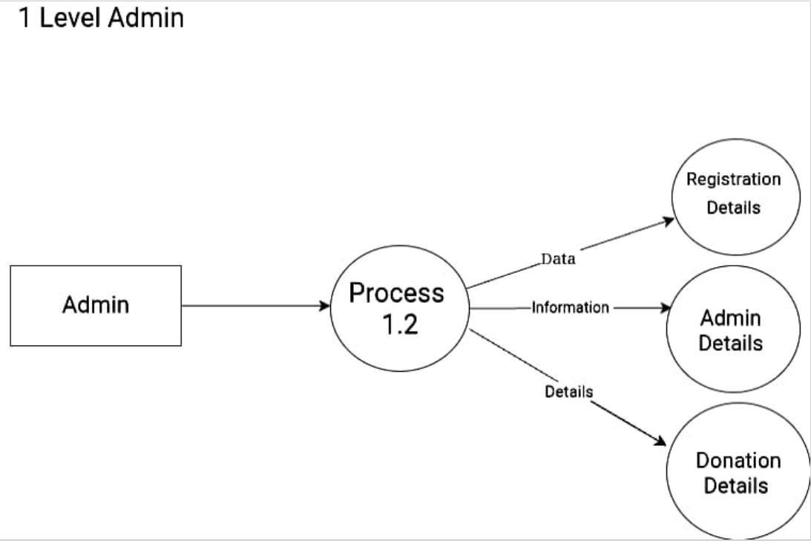

ER Diagram

Activity Diagram

Use Case

Process Flow

Data Dictionary

Implementation
Screenshot
- login
client 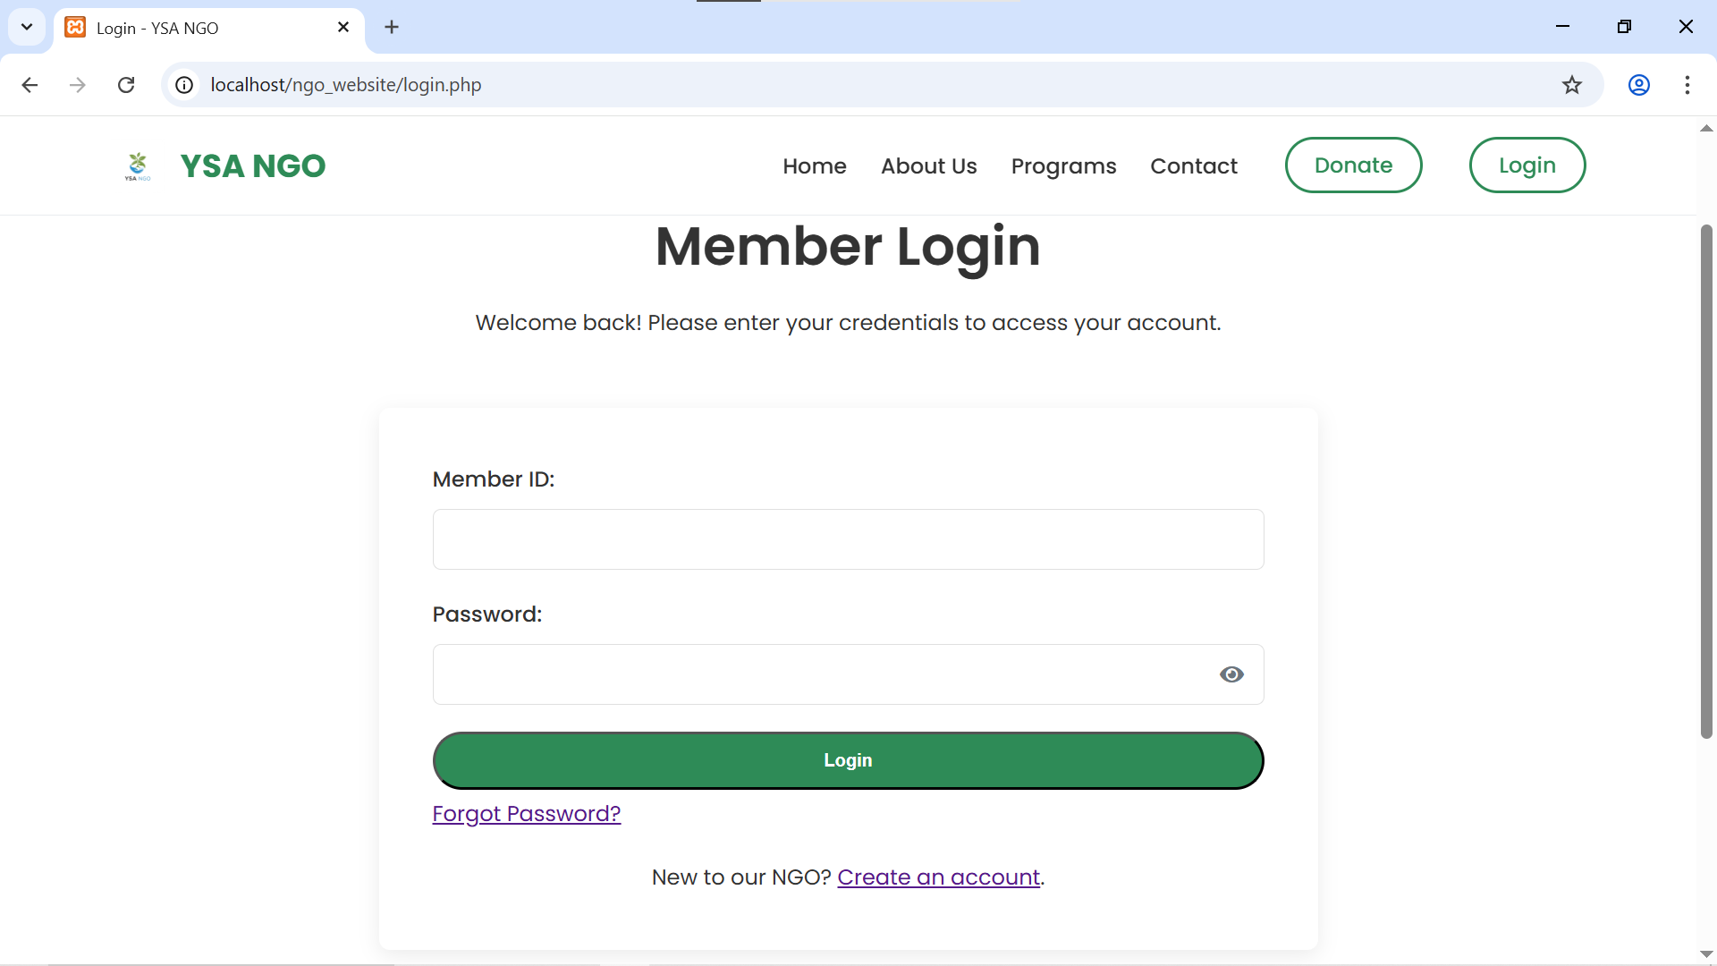
admin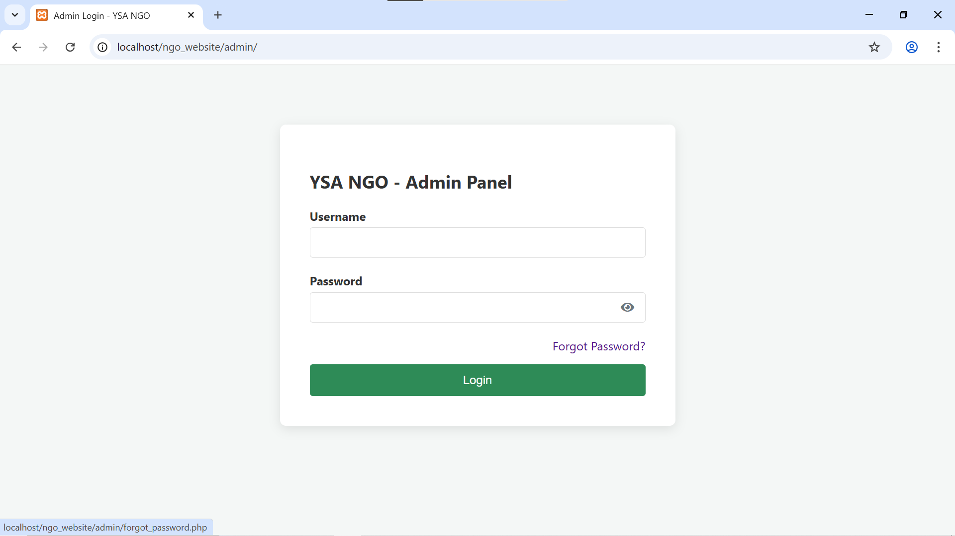

- registration
client
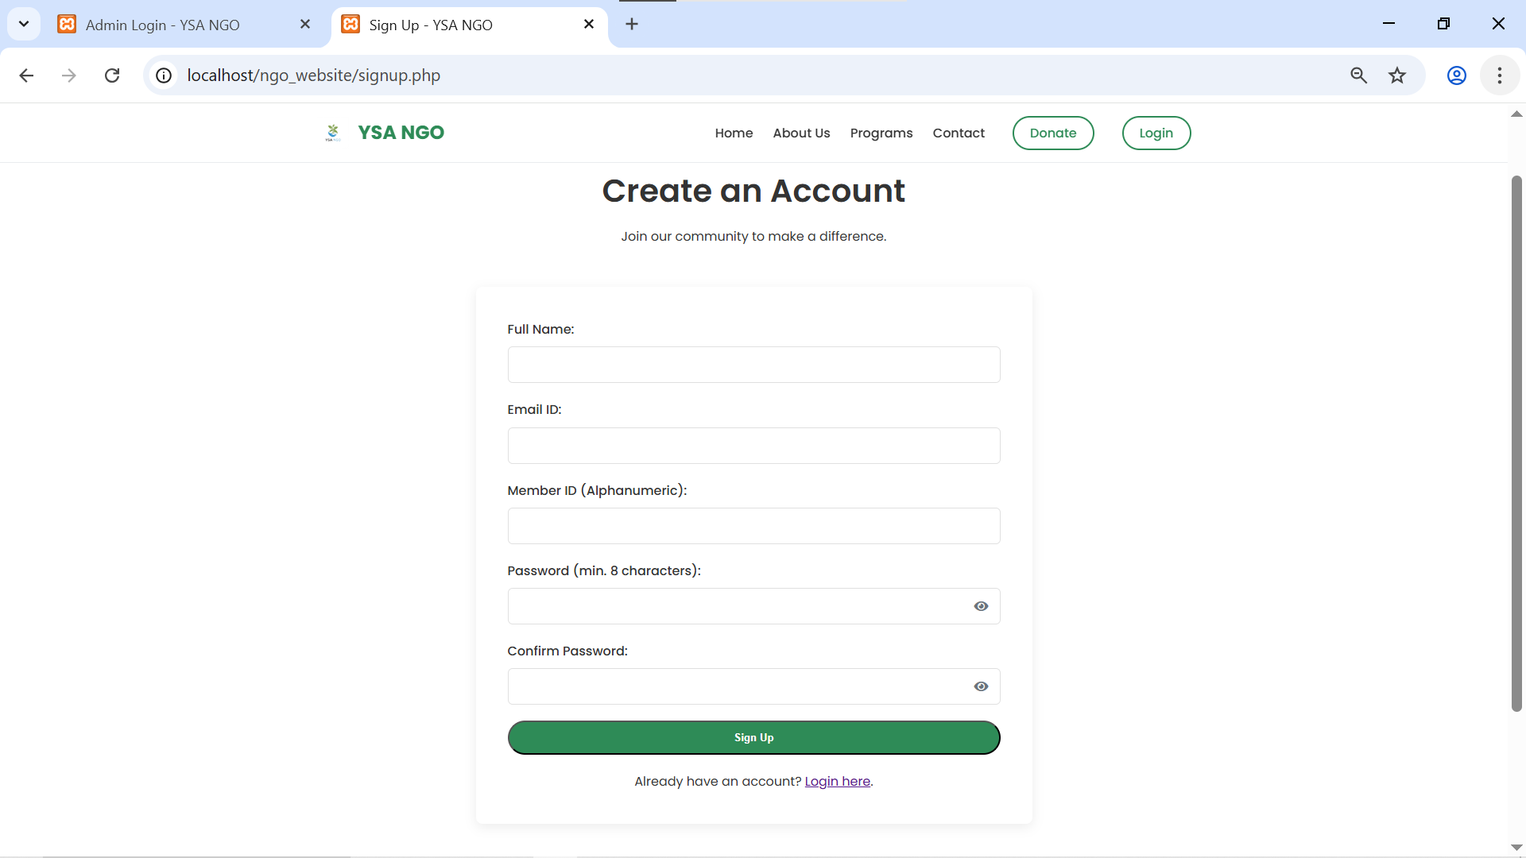
admin
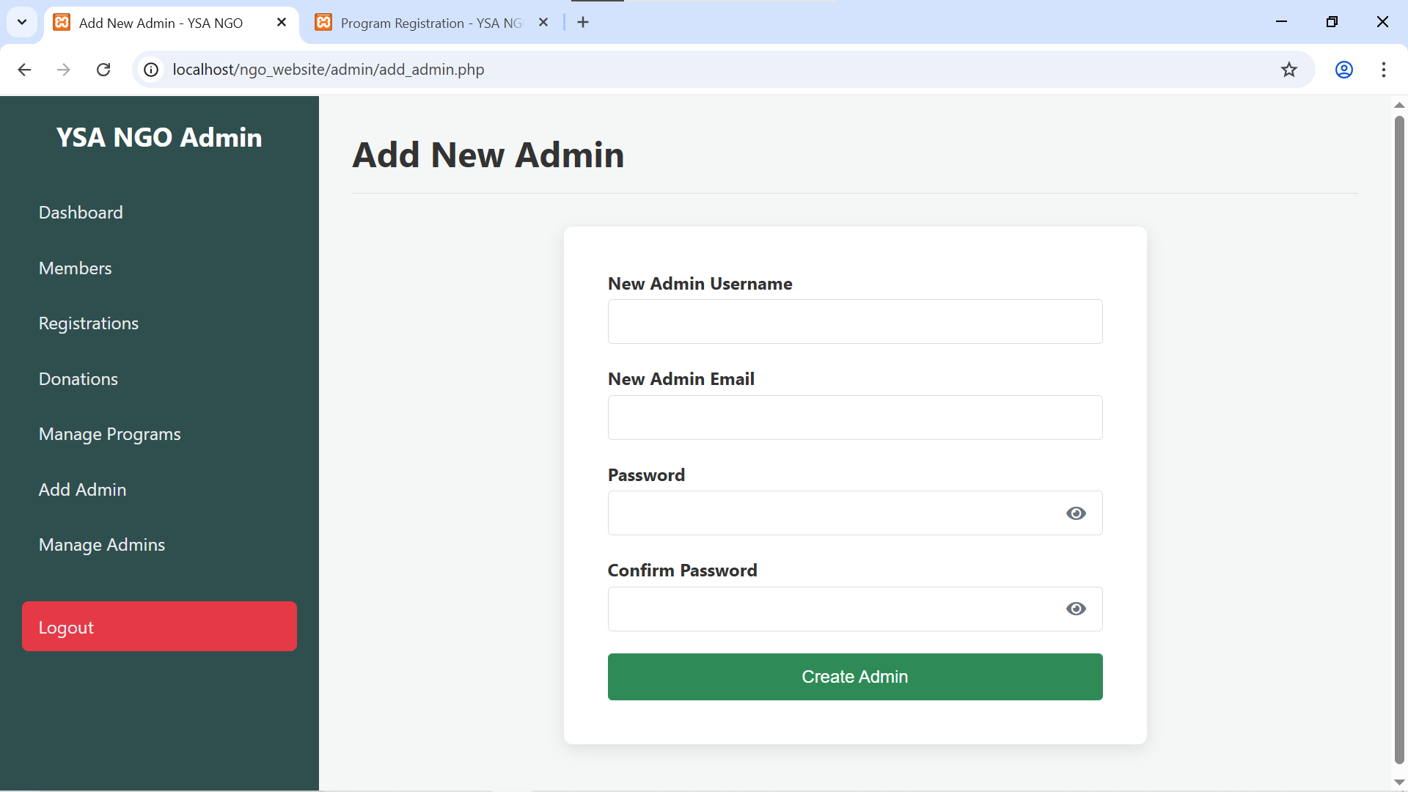

Code Explanation

Testing
Test Case
Test Case ID: TC_001
Test Case Name: Login with valid credentials
Module: User Authentication
Preconditions: User must be registered in the system.
Test Steps:
Open the application.
Go to the login page.
Enter valid username: testuser.
Enter valid password: Test@123.
Click on the "Login" button.
Expected Result: User should be logged in and redirected to the dashboard.
Actual Result: (To be filled after execution)
Status: Pass/Fail

Result
Test Case ID: TC_001
Test Case Name: Login with valid credentials
Module: User Authentication
Preconditions: User must be registered in the system.
Test Steps:
Open the application.
Go to the login page.
Enter valid username: testuser.
Enter valid password: Test@123.
Click on the "Login" button.
Expected Result: User should be logged in and redirected to the dashboard.
Actual Result: User successfully logged in and dashboard displayed.
Status: Pass ✅

Conclusion and Future Scope
The project successfully achieved its objectives by developing a functional and user-friendly software application. All the planned modules were implemented, tested, and verified to ensure correctness and efficiency. The project enhanced understanding of software development life cycle (SDLC), testing methodologies, and practical coding skills. Overall, the system meets the intended requirements and provides a reliable solution to the identified problem.
Future Scope
- Feature Enhancement: Additional features can be added to improve user experience and functionality.
- Automation: Incorporating automated testing and deployment processes to increase efficiency.
- Scalability: Optimizing the system to handle a larger user base or more complex data.
- Security Improvements: Implementing advanced security measures to protect data and prevent unauthorized access.
- Cross-Platform Compatibility: Extending the application to work on multiple platforms (web, mobile) for broader accessibility.
- Integration with Other Systems: Future versions can integrate with external APIs or software to enhance functionality.

